Unveiling Market Insights: Analysing Spending Behaviour and Identifying Opportunities for Growth

NM Id: NM2023TMID09706 1.INTRODUCTION

Overview

* This report serves as a valuable resource for businesses of all sizes and industries seeking to make informed decisions and tailor their strategies to align with consumer demands. With a focus on the intricacies of spending behavior, it will provide a holistic view of market trends, enabling stakeholders to make data-driven choices, optimize resource allocation, and unlock growth potential

Purpose

* We will provide a comprehensive analysis of the factors that influence consumer spending behavior, from economic conditions to shifting demographics and emerging trends.

1. **Problem Definition & Design Thinking**

Empathy Map

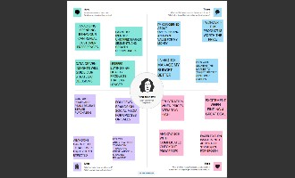

Ideation & Brainstorming Map

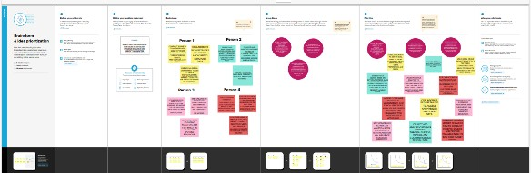

1. **RESULT**

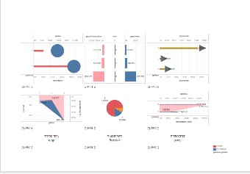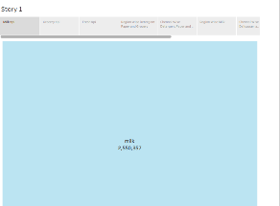

1. **ADVANTAGES & DISADVANTAGES Advantages:**
   * Analyzing spending behavior provides valuable data that can inform strategic decisions. This data-driven approach helps companies make informed choices, reducing the risk of investment in unprofitable areas.
   * Understanding consumer spending habits allows for more precise targeting in marketing efforts. This leads to better ROI on marketing spend.
   * It helps in dividing the market into segments based on spending patterns, enabling companies to tailor their offerings to specific customer groups.

Disadvantages:

* + **Collecting and analyzing consumer spending data can raise privacy concerns, leading to potential backlash and legal issues.**
  + **Inaccurate or incomplete data can lead to flawed insights and misguided decisions.**
  + **Proper analysis of spending behavior often requires significant financial and human resources, which may be prohibitive for smaller businesses.**

1. **APPLICATIONS**
   * **Data Collection**
   * **Data Analysis**
   * **Customer Profiling**
   * **Competitive Analysis**
   * **Feedback and Surveys**
2. **CONCLUSION**
   * **In conclusion, the analysis of spending behavior has provided valuable insights into consumer trends and preferences. These insights can serve as a foundation for identifying opportunities for growth in the market. By understanding how consumers allocate their resources and make purchasing decisions, businesses can tailor their strategies to better meet the needs of their target audience. This data-driven approach to decision-making can lead to more effective marketing campaigns, product development, and overall business growth.**
3. **FUTURE SCOPE**
   * **Gather relevant data on consumer spending behavior. This can include surveys, sales data, social media sentiment analysis, and industry reports.**
   * **Identify current and emerging market trends. This could involve looking at what's hot in your industry and how consumers are responding.**
   * **Study your competitors to understand what strategies are working for them and where they may be falling short.**